ASSESSMENT-1

EXTRACTION, TRANSFORM, LOAD

STEP 1: OPEN POWER Bi APPLICAION.

STEP 2: CLICK ON THE BLANK REPORT AND YOU SEE AN INTERFACE

SCREEN CALLED “CANVAS”.

STEP 3: CLICK ON THE GET DATA ON THE TOP AND SELECT THE FILE

OF REQUIRED TYPE.

STEP 4: ONCE THE FILE SELECTED WAIT FOR A FEW SECONDS AND

THE FILE IS VISBILE WITH SOME OPTIONS ON THE LOWER

SIDE. (LOAD, TRANSFORM, CANCEL).

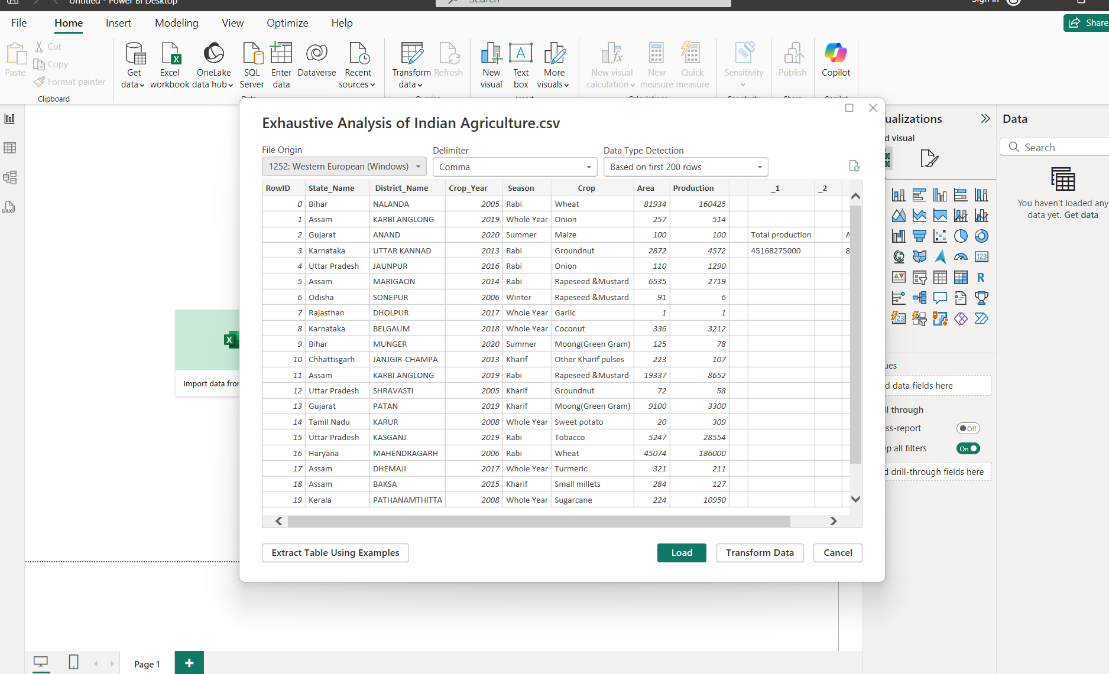STEP 6: WE CAN SEE THE DATA IS LOADED TO POWER Bi APPLICATION.

STEP 7: DIFFERENT VIEW TYPES ARE PRESENT ON THE LEFT SIDE.

STEP 8: CLICK ON THE TRANSFORM DATA ON THE TOP AND THEN

CHOOSE TRANS FORM DATA.

STEP 9: IT REDIRECTS TO THE POWER QUERY EDITOR.

STEP10: ON THE RIGHT SIDE IN THE APPLIED STEPS SECTION, WE CAN

SEE THE OPERATIONS/MANIPULATIONS THAT ARE DONE BY

THE USER.

STEP 11: TO DELETE A COLUMN RIGHT CLICK THE COLUMN AND

CHOOSE REMOVE.

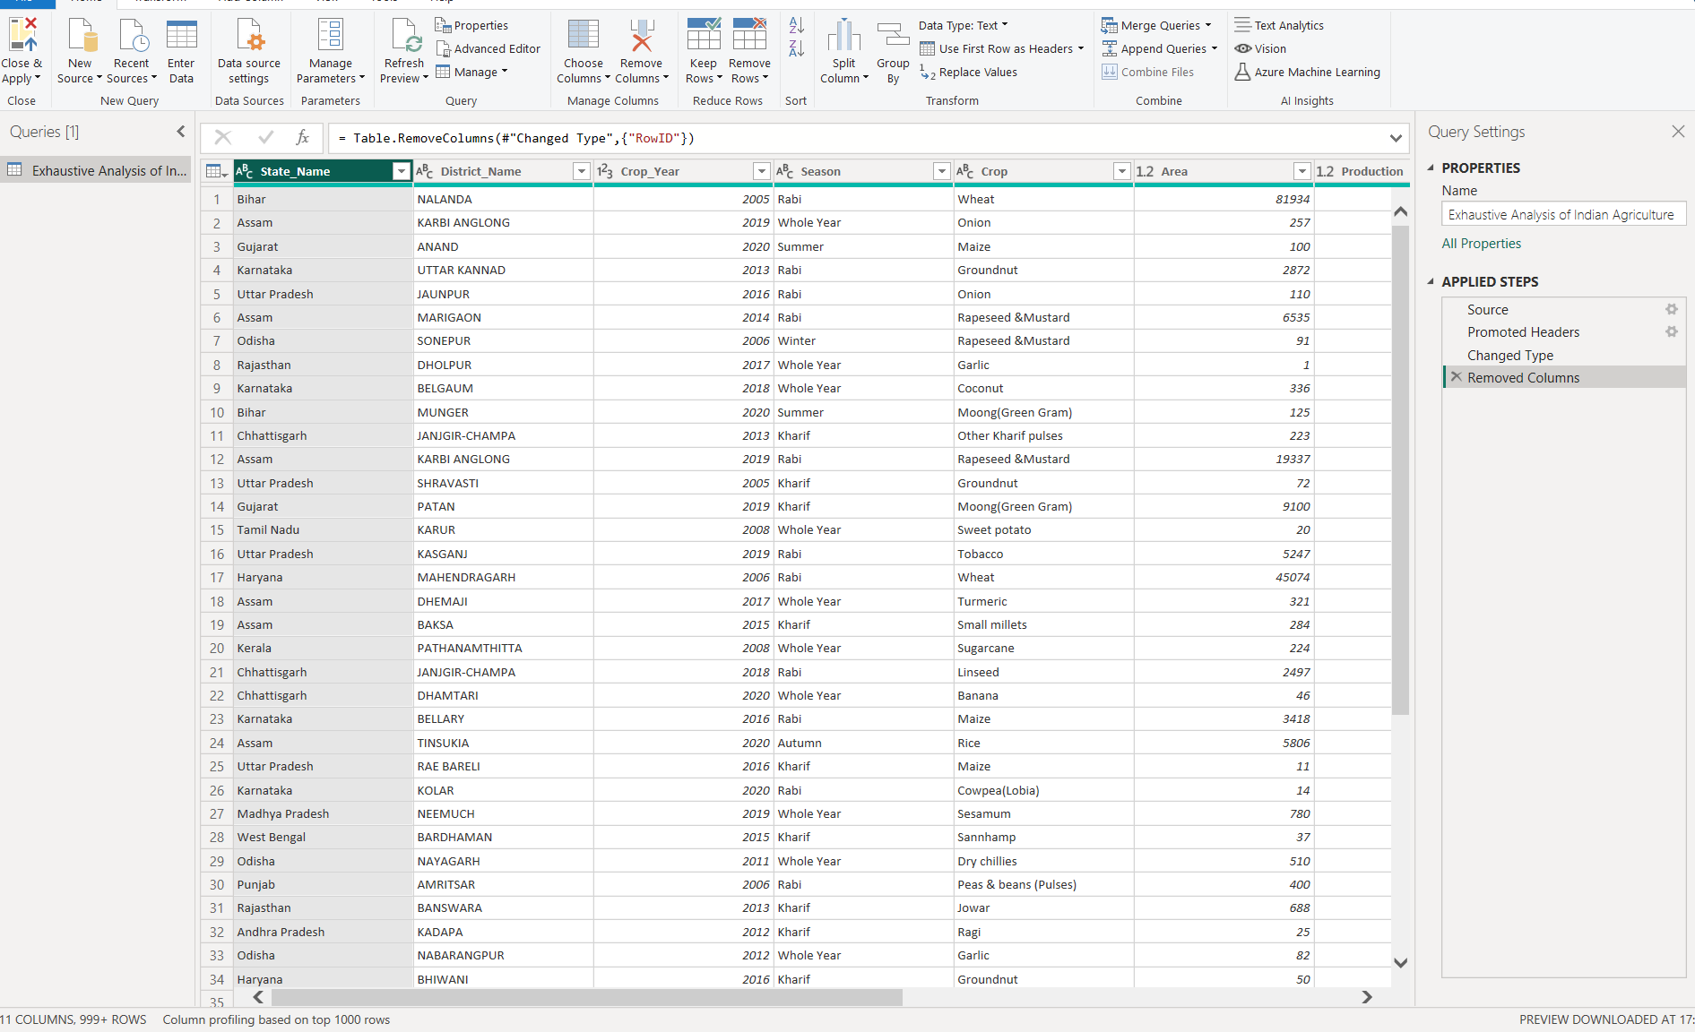

STEP 12: IN THE ABOVE IMAGE ROW ID IS REMOVED.

STEP 13: TO UNDO THE PREVIOUS STEP(S) CLICK ON THE CROSS MARK

BESIDE THE STEP IN THE APPLIED STEPS SECTION.

STEP 14: TO SAVE THE UPDATED DATA CLICK ON THE CLOSE AND

APPLY OPTION ON TH TOP LEFT AND CHOOSE CLOSE AND

APPLY.IT WILL BE REDIRECTED TO POWRER Bi.